Lesson 3.6. Scale and Indirect Measurement.

Learning objectives for this lesson – By the end of this lesson, you will be able to:
- Use scale on a map.
- Solve problems using scale drawings.
- Use similar figures to measure indirectly.

California State Standards Addressed: Algebra I (13.0)

Introduction.
We are occasionally faced with having to make measurements of things that would be difficult to measure directly: the height of a tall tree, the width of a wide river, even the distance between two cities separated by mountainous terrain. In such circumstances, measurements can be made indirectly, using proportions and similar triangles. Such indirect methods link measurement with geometry and number. In this lesson we will examine some of the methods for making indirect measurement.

3.6.1. Use scale on a map.
A map is a two-dimensional, geometrically accurate representation of a section of the Earth’s surface. Maps are used to show, pictorially, how various geographical features are arranged in a particular area. The scale of the map describes the relationship between distances on a map and the corresponding distances on the earth's surface expressed as a fraction or a ratio.

So far we have only written ratios as fractions, but outside of mathematics books, ratios are often written as two numbers separated by a colon (:). They are related to fractional ratios as follows:

Ratio | is read as | equivalent to
1:20 | one to twenty | $$\left(\frac{1}{\text{20}}\right)$$
2:3 | two to three | $$\left(\frac{2}{3}\right)$$
1:1000 | one to one-thousand

Look at the last row. In a map with a scale of 1:1000 (“one to one-thousand”) one unit of measurement on the map (1 inch or 1 centimeter for example) would represent 1,000 of the same units on the ground. A 1:1 (one to one) map would be a map as large as the area it shows!

Example 1
Anne is visiting a friend in London, and is using the map below to navigate from Fleet Street to Borough Road. She is using a 1:100,000 scale map, where 1 cm on the map represents 1km in real life. Using a ruler, she measures the distance on the map as 8.8 cm. How far is the real distance from the start of her journey to the end?
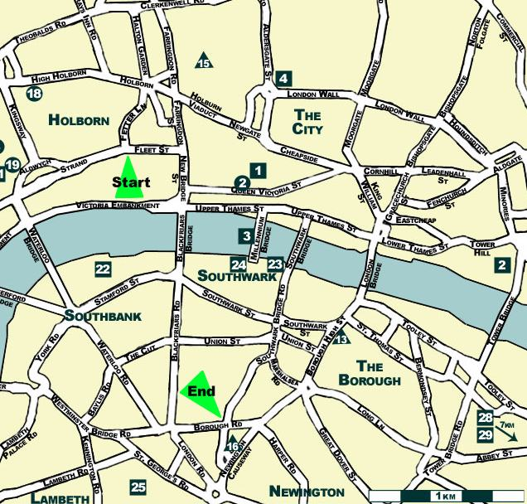
The scale is the ratio of (distance on the map) to the corresponding (distance in real life). In other words:
$\frac{\text{dist}\text{.}\text{ on map}}{\text{real dist}\text{.}}=\frac{1}{\text{100},\text{000}}$
We can substitute in the information we have to solve for the unknown – the distance in real life:
$\frac{8\text{.}\text{8 cm}}{\text{real dist}\text{.}}=\frac{1}{\text{100},\text{000}}$ - cross multiply:
100,000(8.8 cm) = real dist = 880,000 cm - 100cm = 1 m:
real dist. = 8,800 meters - 1,000 meters = 1 km:
Solution: The distance from Fleet Street to Borough Road is 8.8 km.

We could, in this case, use our intuition: the 1cm = 1km scale indicates that we could simply use our reading in centimeters to give us our reading in km. This is not always the case!

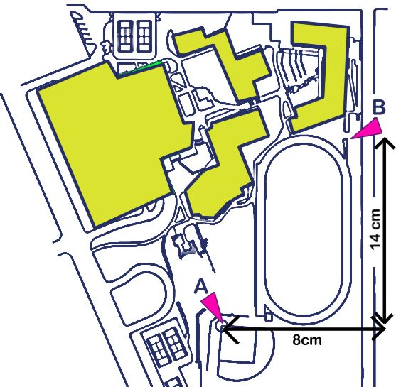
Example 2
Peter is drawing a map of his school for a project in math. He has drawn out the following map of the school buildings and the surrounding area:

He is trying to determine the scale of his figure. He knows that the distance from the point marked A on the baseball diamond to the point marked B on the athletics track is 352 meters. Use the dimensions marked on the drawing to determine the scale of his map.

We know that the real-life distance is 352 m. To determine the scale we use the ratio:
Scale = $\frac{\text{disance on map}}{\text{distance in real life }}$

To find the distance on the map, we will use Pythagoras’ Theorem: a² + b² = c²:

(Distance)² = 8² + 14² = 64 + 196 = 260

Distance = $\sqrt{\text{260}}$= 16. 12 cm

Scale = $\frac{\text{16}\text{.}\text{12}\text{cm}}{\text{352}m}$ - 1 m = 100 cm
Scale = $\frac{\text{16}\text{.}\text{12}\text{cm}}{\text{35200}\text{cm}}$ - divide top and bottom by 16.12:

Scale = $\frac{1}{\text{2183}\text{.}\text{01}}$ - round to 2 significant figures:

Solution: the scale of Peter’s map is approximately 1:2,200

3.6.2. Solve problems using scale drawings.
Another visual use of ratio and proportion is in scale drawings. Scale drawings are used extensively by architects (and often called plans). They are used to represent real objects, and are drawn to a specific ratio. The equations governing scale are the same as for maps – we will restate the equations in forms where we can solve for scale, real distance, or scaled distance:

Scale = $\frac{\text{disance on diagram}}{\text{distance in real life }}$ - rearrange to find the distance on the diagram:
(Distance on the diagram) = (Distance in real life) × (Scale)
(Distance in real life) = $\frac{\text{disance on diagram}}{\text{scale }}=(\text{disance on diagram})⋅\left(\frac{1}{\text{scale}}\right)$

Be careful with precision in scale diagrams – including more than 3 significant figures in your final answer indicates that you can draw with accuracy better than 1 in 1,000. Mostly you should round to 2 or 3 s.f.

Example 4
John is trying to make a scale drawing of the Titanic, which he knows was 883 feet long He would like his drawing to be 1:500 scale. How long, in inches, must the paper that he uses be?

This problem is solved fairly easily – we can reason intuitively that since the scale is 1:1000 that the paper must be $\left(\frac{\text{883}}{\text{500}}\right)$= 1.766 feet long. Converting to inches gives the length at 12(1.766) inches:
Solution: John’s paper should be 22 inches long (rounding up)

Example 4
The Rose Bowl stadium in Pasadena California measures 880 feet from north to south and 695 feet from east to west. A scale diagram of the stadium is to be made. If 1 inch represents 100 feet, what would be the dimensions of the stadium drawn on a sheet of paper?
We will use the relationship:
(Distance on the diagram) = (Distance in real life) × (Scale)
Scale = 1 inch to 100 feet = $\left(\frac{1\text{inch}}{\text{100}\text{feet}}\right)$
Width on paper = 880feet ×$\left(\frac{1\text{inch}}{\text{100}\text{feet}}\right)$ = 8.8 inches - notice that the units of feet cancel!
Height on paper = 695feet ×$\left(\frac{1\text{inch}}{\text{100}\text{feet}}\right)$ = 6.95 inches
Solution: The dimensions of the scale diagram would be 8.8 inches by 6.95 inches.
Example 5
The scale drawing below is sent to kids who attend Summer Camp. Use the scale to estimate the following:
(i) The distance from the mess hall to the swimming pool via the path shown.
(ii) The distance from the lodge to the swimming pool via the horse corral.
(iii) The direct distance from the mess hall to the lodge

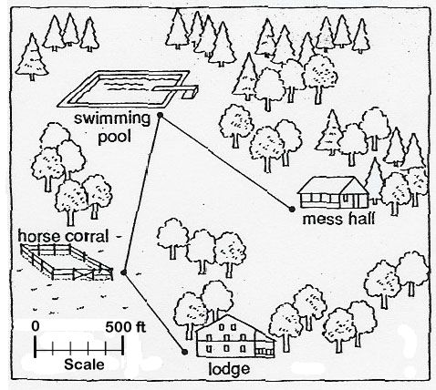
To proceed with this problem, we need a ruler. It does not matter whether we use a ruler marked in inches or centimeters, but a centimeter scale is easier, as it is marked in tenths. For this example the ruler used will be a centimeter ruler.

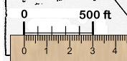
We first need to convert the scale on the diagram into something we can use – often the scale will be stated on the diagram but it is always worth checking, as the diagram may have been enlarged or reduced from its original size. Here we see that 500 feet on the diagram is equivalent to 3.0 cm on the ruler. The scale we will use is therefore 3 cm = 500 feet or:
Scale = $\left(\frac{3\text{cm}}{\text{500}\text{ft}}\right)$ - do not worry about canceling units this time!

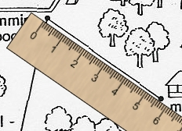
(i) We are now ready to move to the next step – measuring distances on the diagram. We first wish to know the distance from the mess hall to the swimming pool. We measure the distance with our ruler. We find that the distance is 5.6 cm. We divide this by the scale to find the real distance:
$\frac{\text{disance on diagram}}{\text{scale }}=5\text{.}6\text{cm}⋅\left(\frac{\text{500}\text{ft}}{3\text{cm}}\right)$
Multiply out – note that the centimeter units will cancel leaving the answer in feet:

Solution: The distance from the mess hall to the swimming pool is approximately 930 feet (rounded to the nearest 10 feet)

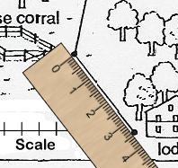
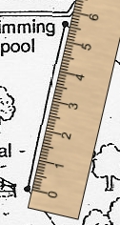
(ii) To find the distance from the lodge to the swimming pool we have to measure 2 paths: the first is the distance from the lodge to the horse corral. This is found to be 3.4 cm.
The distance from the corral to the swimming pool is 5.5 cm.
The total distance on the diagram is thus (3.4 + 5.5) = 8.9 cm.
Distance in real life = $\frac{\text{disance on diagram}}{\text{scale }}=8\text{.}9\text{cm}⋅\left(\frac{\text{500}\text{ft}}{3\text{cm}}\right)$

Solution: The distance from the lodge to the pool is approximately 1480 feet

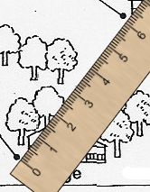
(ii) To find the direct distance from the lodge to the mess hall, we simply use the ruler to measure the distance from one point to the other. We do not have to go round the paths in this case.
Distance on diagram = 6.2 cm
Distance in real life = $\frac{\text{disance on diagram}}{\text{scale }}=6\text{.}2\text{cm}⋅\left(\frac{\text{500}\text{ft}}{3\text{cm}}\right)$
Solution: The distance from the lodge to the mess hall is approximately 1030 feet

3.6.3. Use similar figures to measure indirectly.
Similar figures are often used to make indirect measurement. Two shapes are said to be similar if they are the same shape but one is an enlarged (or reduced) version of the other. Similar figures have the same angles, and are said to be “in proportion” – the ratio of every measurable length in one figure to the corresponding length in the other is the same. Similar triangles crop up often in indirect measurement:

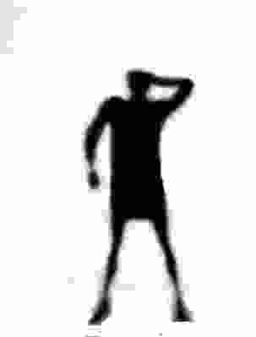
Example 6
Mirror
Andrew is visiting Paris, and wants to know the height of the Eiffel Tower. Unable to speak French, he decides to measure it in the following way:
- He measures out a point 500 meters from the base of the tower, and places a small mirror flat on the ground.
- He stands behind the mirror in such a spot that standing upright he sees the top of the tower reflected in the mirror.
- He measures both the distance from the spot where he stands to the mirror (2.75 meters) and the height of his eyes from the ground (1.8 meters).
Explain how he is able to determine the height of the Eiffel Tower from these numbers and determine what that height is.

First we will draw and label a scale diagram of the situation:
x
500 m
2.75 m
1.8 m

We know that the angle that the light reflects off the mirror is the same as the angle that it hits the mirror at.

Both triangles are right triangles, and both have 1 other angle in common – that means that all three angles in the large triangle match the angles in the smaller triangle – we same the triangles are similar: exactly the same shape, but enlarged or reduced.

- This means that the ratio of the long leg in the large triangle to the length of the long leg in the small triangle is the same ratio as the length of the short leg in the large triangle to the length of the short leg in the small triangle:
$\frac{\text{500}m}{2\text{.}\text{75}m}=\frac{x}{1\text{.}8m}$ - multiply both sides by 1.8m:
$1\text{.}8m⋅\frac{\text{500}}{2\text{.}\text{75}}=x$
Solution: The Eiffel Tower, according to this calculation, is 327.3 meters.

Example 7
Andrew is looking at a lighthouse and wondering how high it is. He notices that it casts a long shadow, which he measures at 200 meters long. At the same time he measures his own shadow at 3.1 meters long. Andrew is 1.9 meters tall. How tall is the lighthouse?

We will again draw a scale diagram:

Again we see that we have two right triangles.
x
200 m
3.1 m
1.9 m
The angle that the sun causes the shadow from the lighthouse to fall is the same angle that Andrew’s shadow falls. We have 2 similar triangles, so we can again say that the ratio of the corresponding sides is the same:
$\frac{\text{200}m}{3\text{.}1m}=\frac{x}{1\text{.}9m}$ - multiply both sides by 1.9m:
Solution: The lighthouse is 122.6 meters tall.
Homework Problems
- Use the map in example one. Using the scale printed on the map determine the distances (rounded to the nearest half km) between:
a. Points 1 and 4
b. Points 22 and 25
c. Points 18 and 13
c. Tower Bridge and London Bridge

- The scale diagram in example 5 does not show the buildings themselves in correct proportion. Use the scale to estimate:
  - The real length the indicated pool would be if it was drawn in proportion
  - The real height the lodge would be if it was drawn in proportion
  - The length a 50ft pool would show as on the diagram.
  - The height a 20ft high tree would show as on the diagram
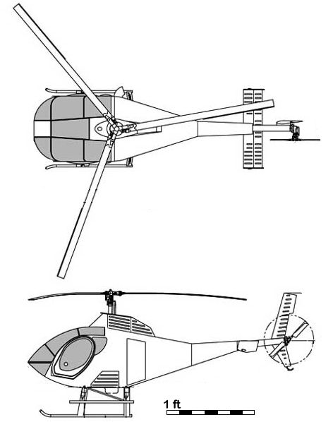

- Use the scale diagram to the right to determine:
  - The length of the helicopter (cabin to tail)
  - The height of the helicopter (floor to rotors)
  - The length of one main rotor
  - The width of the cabin
  - the diameter of the real rotor system

4. On a sunny morning, the shadow of the Empire State Building is 600 feet long. At the same time, the shadow of a yardstick (3 feet long) is 1 foot, 5¼ inches. How high is the Empire State building?

Answers
1. a. 3 km; b. 7 km; c. 12½ km; d. 4½ km
2a. Pool = 600 feet long; Lodge = 250 feet high; c. Pool should be 0.3cm; d. Tree should be 0.12cm
3. a. length = 21ft; b. height = 10ft; c. Main rotor = 12ft; d. cabin width = 5½ ft; e. rotor diameter = 4ft
4. 1250ft

